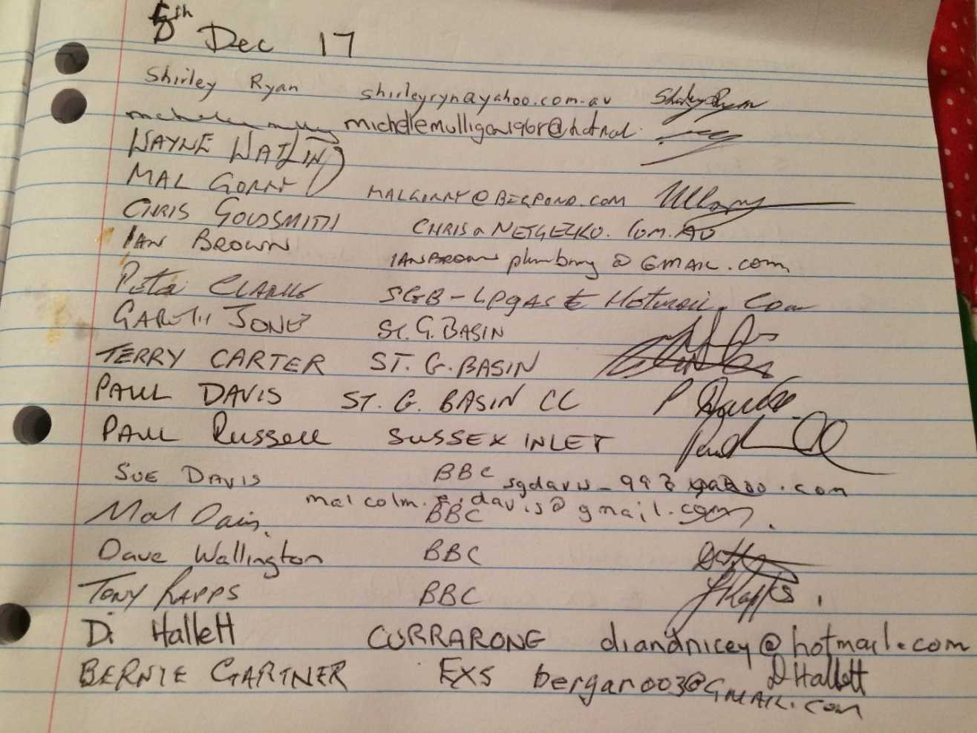
Apologies:
Mick Boyd
Minutes from last AGM 2nd Feb 2017 were read (Bernie Gartner)
Amendment to minutes that Bomaderry Bowling Club did donate $150
To SDB&SA

Treasurers report
Ballance was $2,562.14
Moved Sue Davis that the Treasurers report be accepted
Seconded…
All in favour

Bernie stepped down from Presidency and gave the chair to Paul Davis for elections of 2018 committee
Paul thanked the outgoing committee.
Well done
Election of Committee
President
Gareth Jones nominated himself For President
Seconded Shirley Ryan
All in favour
Gareth Accepted

Vice President
Tony was nominated
Seconded Shirley Ryan
All in favour
Tony Accepted

Secretary
Tony Rapps nominated Shirley Ryan
Seconded Mal Davis
All in favour
Shirley Accepted

Treasurer
Sue Davis was nominated
Seconded Mal Davis
All in favour
Sue accepted

Match secretary
Bernie nominated Mal Davis
Seconded Tony Rapps
All in favour
Mal Davis asked to wait to see how the comp will be run before accepting

Later accepting

Recorder
Nominate Dave Hazel

General business
Gareth Jones thanked the old committee

Bernie nominated Sue Davis for a life membership
Seconded Tony Rapps
All in favour
Sue Accepted
Discussion on handicaps and club teams

C Grade
Bernie moved that C Grade 2018 be handicap
Di seconded
All in favour
A Grade
Chris Goldsmith moved that A Grade stays off scratch
Seconded Paul Davis
5 voted for
2 voted against
Carried

B Grade
Peter Clark moved that B Grade stays off scratch
Seconded Mal Davis
4 voted for
2 against
Carried

Each club please promote their own snooker Clubs

Next Meeting will be at Ex Services Club
On 1st Feb 2018

Meeting closed at 8.32pm

