Meeting opened 7.08pm
Attendance:
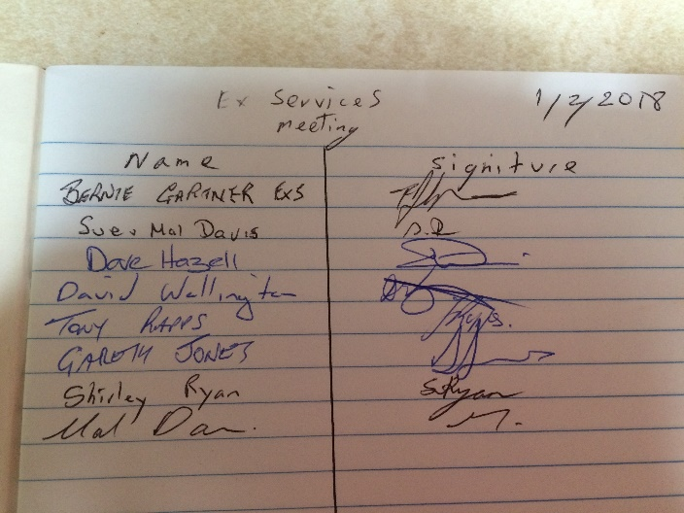
Apologies:
Peter Clarke
Minutes of last meeting AGM read.
nothing arising from minutes.
Tony moved that the minutes be accepted
Seconded Dave
All in favor

Secretaries report
Paul emailed Templates to me for the players memorial. I will be notified when to send to all clubs.
I sent the minutes to David, so he could put them on the website and to clubs I could find email addresses.
Shirley asked if she can just put the minutes only on the Website for clubs to download and put up on their notice board.
All in favor
Tony moved that the secretary’s report be accepted
Dave seconded
All in favor
Treasurers report
Ballance $2,485.91
Australia Gooday emailed a bill for $77 which has been paid.
Bank interest .51c
Discussion on bank signatures
Sue will check on who is still on bank account
Moved Sue Davis that the Treasurers report be accepted
Seconded Mal
Recorders report
David put the minutes of AGM on the website
The score sheet is going to be revised to make it easier for everyone.
David is setting up one email address for everyone to send their results.
Moved Mal that the recorders minutes be accepted
Seconded Dave
All in favor

Handicap report
C grade handicaps discussed
Mal suggested to divide c grade into 4 groups
Top group on zero
Next on 5
Next on 10
Last on 15
Mal moved that this system be excepted and applied for 12 months
Plus, no foul misses on any grade
Seconded David
All in favor
General business
Next meeting will be on 1st March 7 pm at the basin
All clubs will bring their list of teams and players to this meeting
Comp will start on Monday 19th march
Fees will stay the same as last year
$140 per team and $35 per player
Teams we think we have at the moment
Sussex A = 1 B = 2 C= 1
Basin A = 2 B = 2 C = 2
Exservices A = 1 B = 1 C = 1
Currarong B = 1 C = 1
BBC A = 1 B = 1

Discussion on presentation night
BBC & the Basin will approach their respective clubs to ask for a quote on costs for holding the presentation at their club

Discussion on clothing
To all clubs
Players must dress neat and tidy.
Players must wear a collared shirt.
No shorts or tracky pants will be allowed
Clubs will not respect our sport if we don’t.
David asked if he can have details of championships that he does not have on the website.
Also, any life memberships.
All agreed.

Meeting Closed at 8.05
To all clubs
Please bring details of all teams and players that wish to compete in the 2018 Shoalhaven Snooker Competition to the
Next meeting 1st March 2018 - Basin – 7 pm

To all players.
If there is anything you would like to discuss on any aspect of our snooker competition, please put it in writing to the committee and attend the next meeting of our association.
I will put it on the agenda. Where it can be discussed by all attending.
All input at the meetings would be appreciated to improve our game.
Secretary
Shirley Ryan
shirleyryn@yahoo.com.au

