Meeting opened 7.02pm
Attendance:
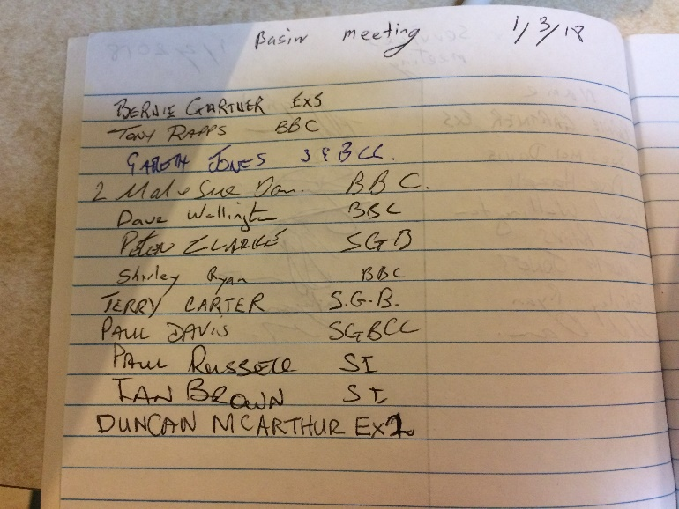
Apologies:
Currarong & David
Minutes of last meeting AGM read.
Business arising from minutes
Membership badges not repaired yet.
Discussion on foul miss rule being remove.
Signatures on bank statements have not been changed. Not needed.
There was no attendance on the site as the picture was missed.
Tony moved that the minutes be accepted
Seconded Dave
All in favor

Secretaries report
I sent the minutes to David, so he could put them on the website.
I have had no correspondence.
Tony moved that the secretary’s report be accepted
Dave seconded
All in favor
Treasurers report
No change to bank account. Sue has a cheque for registration fees at home.
Sue has an account for the website.
Moved Sue Davis that the Treasurers report be accepted
Seconded Bernie
Recorders report
David not in attend

Match secretaries report
No change until teams finalized.
Handicap report
Discussion on handicaps
Bernie Move that we rescind the last meetings handicap decision made for c grade
Seconded Gareth
6 in favor
2 in favor
Dunken Move that we have a fixed handicap which can be reviewed
Seconded Bernie
6 in favor
2 against
Handicap committee
Peter Clarke; Bernie Gartner, Paul Russel, Shirley Ryan & someone from Currarong
General business
Tony has got a quote for this year’s presentation night from the BBC.
$25 a head no desert.
On 1st Dec 2018.
Tony has had the room hire cost wavered as we are a not profit organisation
This was accepted
The handicap committee need to formulate players conditions.
We also need code words to access the Website.
BBC A1 - B2 – C1
Ex servos A1 – B1 – C1
BASIN A2 – B2 – C2
SUSSEX A1 – B2 – C1
CURRARONG B1 – C1
Meeting Closed at 8.35
Next meeting 5th April 2018 - Basin – 7 pm

Secretary
Shirley Ryan
shirleyryn@yahoo.com.au

