Meeting opened 7.10pm
Attendance:
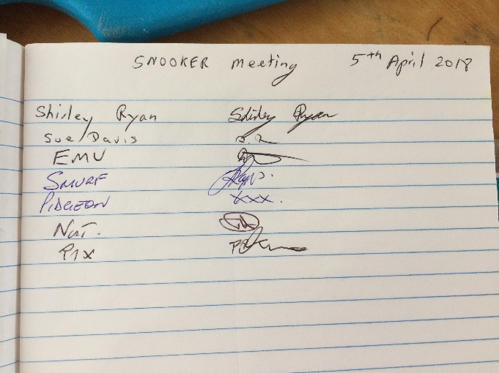
Apologies:
Gareth Jones
Mal Gorry
Minutes of last meeting AGM read.
Tony moved that the minutes be accepted
Seconded
All in favor

Secretaries report
I sent the minutes to David, so he could put them on the website.
I have had no correspondence.
Bernie moved that the secretary’s report be accepted
Tony seconded
All in favor
Treasurers report
Balance $2,346.32
As off the 22nd March
Moved Sue Davis that the Treasurers report be accepted
Emu Seconded
All in favor

Recorders report
Everything is going well
Discussion on sides writing just SUB on the score sheet. This is not allowed.
Teams are reminded all names must be on the sheets before play commences.
Discussion on the playing conditions.
Dave just changing wording as we have brought in handicaps.
Match secretaries report
Calendar of events needs to be put on the Website
Discussion on entry fees into events.
Handicap report
no handicap report
General business
Discussion on teams only having 7 registered players for each team.
Bomaderry’s 2nd side has 8, so one player will be moved to Bomaderry’s 1st side
Players can only register for 1 Team.
They are only allowed to play in another team only 3 times and only when a regular player for that team is unable to play
Discussion on dress rules.
It has been reported that someone has worn shorts to play.
SHORTS ARE NOT ALLOWED
PLAYERS ARE NOT ALLOWED TO PLAY IF THEY ARE NOT FOLLOWING THE DRESS RULES.
THE PLAYER MUST EITHER CHANGE THEIR CLOTHES OR FIND ANOTHER PLAYER TO REPLACE THEM.
Sue brought up that the cost of the presentation night dinner was expensive, just for a main meal.
Sue asked if we could change this to the smorgasbord at ex services club.
This was discussed
Sue moved that we change it to the ex services club
Seconded Shirley
All in Favor.
Next meeting to be confirmed

Secretary
Shirley Ryan
shirleyryn@yahoo.com.au

