Meeting opened 7.10pm
Attendance:
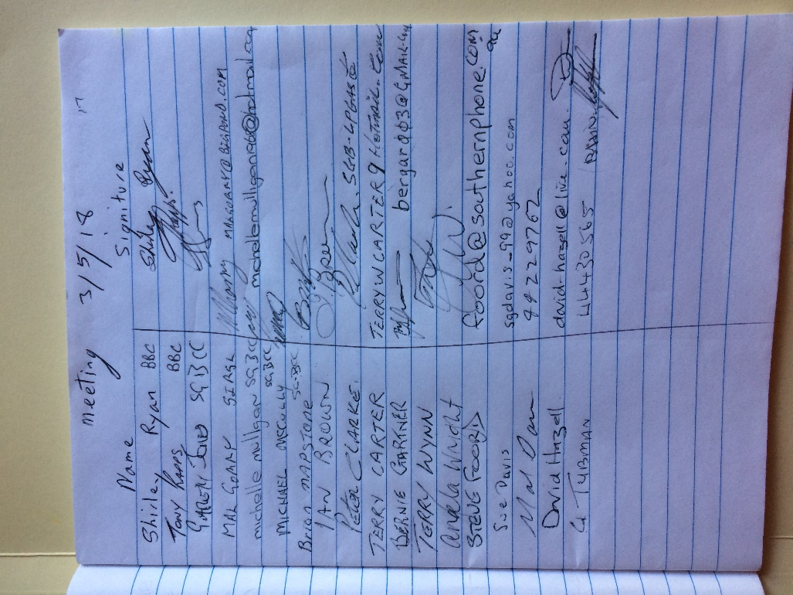
Apologies:
Dave Wallington
Minutes of last meeting AGM read.
Mal Davis moved that the minutes be accepted
Seconded Tony
All in favor

Secretaries report
I sent the minutes to David, so he could put them on the website.
I have handed invitations to all the Clubs for the Vern Ash.
Sue moved that the secretary’s report be accepted
Tony seconded
All in favor

Treasurers report
Balance $6,896.32
Players fee $35
Team fees $1,995.00
Team and player $1,400.00
Moved Sue Davis that the Treasurers report be accepted
Bernie Seconded
All in favor

Recorders report
Happy with the way things are going.
Moved Shirley that the report be accepted
Seconded Mal Davis
All in favor
Match secretaries report
The Doubles Handicap will b on 20th May exservices club.
Names must be in by 11th May
Contact Mal email on website
Handicap report
Discussion on all handicaps. Especially new players.
Handicaps have been changed on the website. Thanks David and Mal.
General business
Mal Davis moved that special dispensation be given to Sussex to bring up B graders for 4 weeks
Seconded Steve Foord
All in Favor

The new players handicaps were assessed on their performance so far into the competition. Some of these and a few other handicaps have been changed. These are on the website.

Discussion on Paul Davis playing on wrong handicap.
Moved Tony that all 3 points be removed from him.
Seconded Mal Davis
All in favor

Presentation Dinner was discussed.
Steve will look into a room for presentation.

Evidence was heard from all parties and witnesses on a fight that happened during c grade comp at the Basin club against the ex services club on Wednesday 18th April.
The executive committee decided that the main players involved had brought the game into disrepute.
The decision was made to give the players 6 weeks suspension and on returning to competition on the week starting on the 18th June, their attitude will be monitored.
Meeting closed at 9.30pm

Next meeting Thursday 5th July at the Exservices Club Nowra
It would be appreicaited if every Club is represented at this meeting allowing all clubs to have a say.
This will allow us all to get on with playing the game we love.
Good luck to all those playing in the district competitions.
Secretary
Shirley Ryan
shirleyryn@yahoo.com.au

