Meeting opened 7.10pm
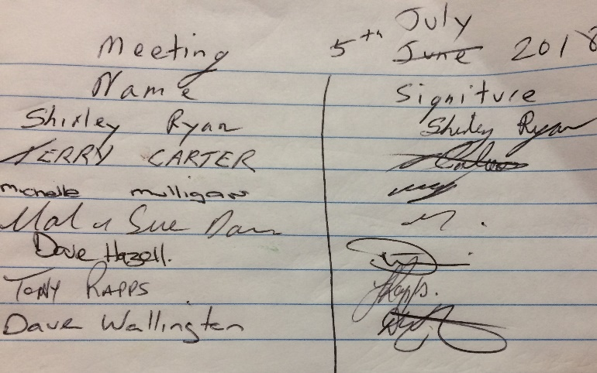
Attendance:
Apologies:
Gareth Jones
Peter Clarke
Bernie Gartner

Minutes of last meeting AGM read.
Amendment made to discussion on wrong handicap. Replaced Paul Davis name with Andi Franchi.
Tony Rapps moved that the minutes be accepted
Seconded
Shirley Ryan
All in favor

Secretaries report
I’ve received 4 letters back from the 4 respective Club involved in the competition this year.
I read each letter.
We have received $300 from the Basin, $300 from the ex-servicemen’s Club, $150 from BBC and nothing from Sussex.
I have written 3 thank you letters to each of the Clubs mentioned, with a receipt from Sue and will pass them on to each Club.
Sue moved that the secretary’s report be accepted
Terry seconded
All in favor
Treasurers report
Balance $8,581.85
Moved Sue Davis that the Treasurers report be accepted
Emu Seconded
All in favor

Recorders report
Everything is going well
Shirley move that the recorders report be accepted
Seconded Michelle
All in favour

Match secretaries report
We’re in the middle of the division 1 & 2 and Mal cant remember division 2 ever having 32 entries. All was going well.
Veterans comp was discussed.
Tony move that the veterans comp be moved to the 11th & 12th August
Seconded Shirley
All in favour

General business
Discussion on C grade ex service team not turning up to play at the Basin Club.
Mal moved that 8 points be awarded to the Basin Team involved the first week and 8 points be awarded to the Basin Team involved the second week plus 4 penalty points for the repeat offence. The 3rd offence will be double.
Seconded Shirley
All in favour
A letter to the ex services snooker club will be sent explaining this ruling.

Discussion on the cost of the players memorial
Sue move that the Players memorial nomination fee be raised to $15
Seconded Mal
All in favour

Discussion on the date of players memorial shield.
It was decided that because The Basin is a main sponsor of this tournament that we change the date to later in the year when the basins new snooker room will be up and running. This will make it fair to all players nominating for this tournament as well.

It was also decided to move the rest of division 2 to the ex servicemens club as they have 3 tables.
David will put it on the website.

David suggested that if handicaps are used again next year that new players start on 50%.
A few handicaps have been changed owing to extreme %

Tony put a complaint in about the disgusting language used by Clint Hanlon at the A grade comp recently.
A letter will be sent to Basin Club on this behavior. This will contain a warning that this language especially the C word will not be tolerated and there will be consequences for a repeat offence reported.

Can the Secretary of each snooker club be reminded to download all information off the website and place it on their own Snooker Board, so all players can read it.
Also, players are reminded that they cannot confront committee members with complaints other than at a committee meetings.
Also players are reminded that if they referee games they must follow refereeing rules.

Next meeting to be at the Basin
7pm on 2nd August

Secretary
Shirley Ryan
shirleyryn@yahoo.com.au

