Meeting opened 7.00pm
Attendance:
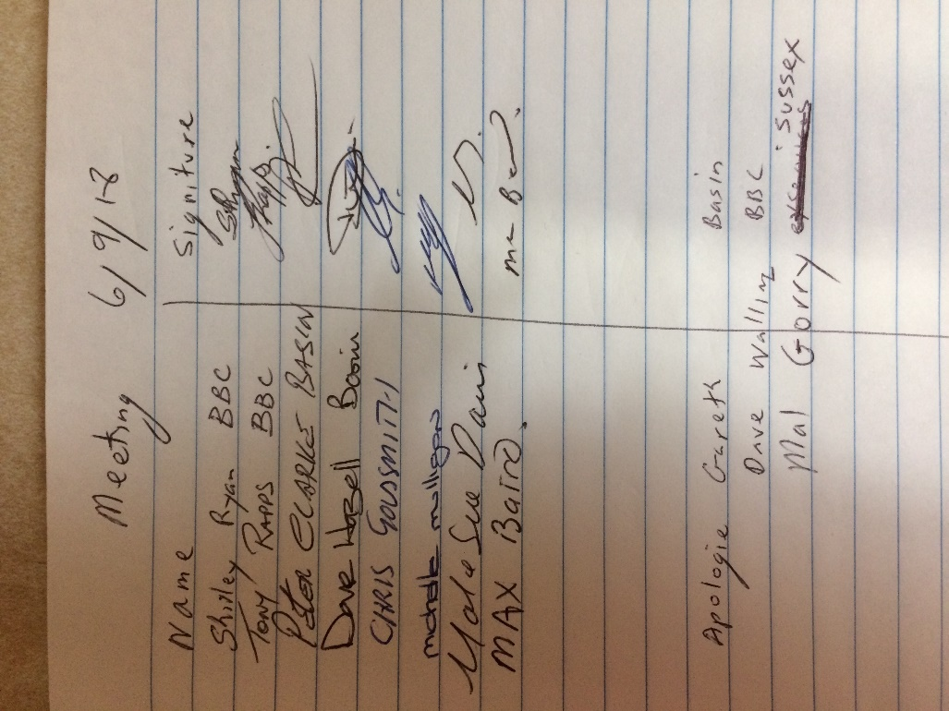
Apologies:
Gareth Jones
Dave Wallington
Mal Gorry

Minutes of last meeting AGM read.
Mal Davis moved that the minutes be accepted
Seconded Peter Clarke
All in favor
Secretaries report
I have received a letter of apology from Clint Hanlon. It says he will do his best to make sure this does not happen again.
Shirley read a letter from Peter Clarke to the Committee about Alan Bird not turning up at the meeting organized my him to discuss c grade & to ask why the snooker rooms were closed at short notice for a semifinal.
I read out the reply letter from Alan Bird, which did not really answer these questions.
Moved the secretary report be accepted
Michelle seconded
All in favor

Treasurers report
Balance $8,732.94
Moved Sue Davis that the Treasurers report be accepted
Dave Seconded
All in favor
Recorders report
Discussions on handicaps for next year.
More discussions at AGM
Shirley move that the recorders report be accepted
Sue Seconded
All in favour
Match Secretaries report
Mal discussed A grade grand final.
It was an excellent night of snooker
Chris move that the Match Secretaries report be accepted.
Seconded Michelle
All in favour
General business
Tony read a letter on what happened at the meeting held on the Friday about the C grade.
It was voted that the original decision will stand.
Discussion on this, and it was deciding that this was the end of this matter.
I will send a letter to the ex-services snooker president and let him know of our decision.

We also discussed the ex services snooker room being closed.
I will send a letter to the club manager and ask why the tables we closed and ask what we have to do in the future to see this doesn’t happen again.

Chris brought up the memorial being played at the Basin and not sure if the room will be ready.
Also, their looking at running a summer comp.

Discussion if we are still having presentation night at exservices club.
We are looking at a date for next year.
We are going to change the date for this year to 17th November.
Please send numbers from each club by the 3rd November for presentation night
Next meeting to be at ex -services
7pm on Thursday 1st November
Secretary
Shirley Ryan
shirleyryn@yahoo.com.au

