Meeting opened 7.00pm
Attendance:
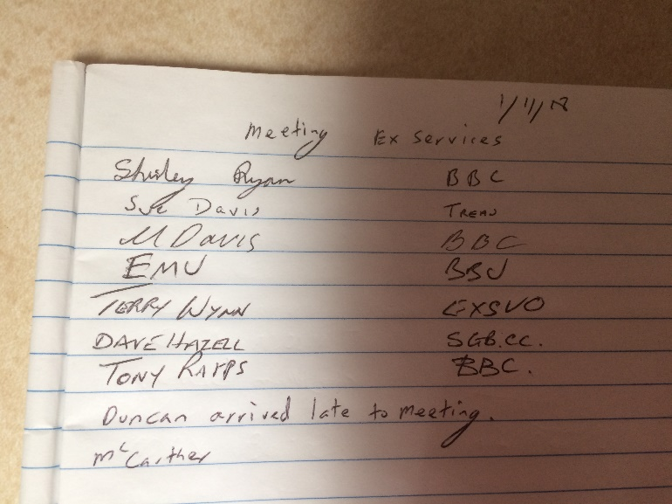
Apologies:
Bernie Gardner
Michelle Mulligan
Terry Carter
Peter Clarke
Angela Wright

Minutes of last meeting read.
Tony moved that the minutes be accepted
Seconded Emu
All in favor

Secretaries report
I sent a letter to Alan Bird about our decisions on C Grade.
He replied with the same answers as last time.
I also sent a letter to the Club asking why the Snooker room was closed and how we can fix this in the future. No reply.

Treasurers report
Balance $8,735.83
Moved Sue Davis that the Treasurers report be accepted
Seconded Shirley
All in favor

Recorders report
Match Secretaries report
Mal has done the draw for the Players Memorial.
Dave Hazel had reprinted it onto the computer and put it on the website.
Late Players can replace early forfeits.

General business
Mal said the trophies are being made by Adrian.
All winning teams wanted to receive prize money for their wins.
Mal has worked out roughly what the prize money for the players memorial will be.
He will add $150 to the re-precharge prize money from the donations
Players must play on Saturday to be able to play in the repercharge on Sunday.
Dave asked for all previous winners to put on the website.
Discussion on what handicaps might be next year.

Next meeting will be the
AGM at ex -services
7pm on Thursday 6th December
PLEASE MAKE SURE YOUR CLUB IS REPRESENTED AT THIS AGM

Secretary
Shirley Ryan
shirleyryn@yahoo.com.au
A reminder presentation night will be on
Saturday 17th Nov around 6.30pm

