Meeting opened 7.20pm
Attendance:
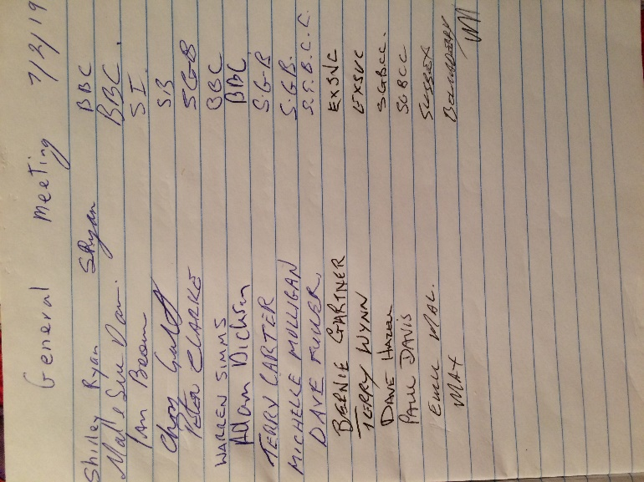
Apologies:
none

Minutes of last General meeting read.
Sue Davis moved that the minutes be accepted
Seconded Bernie Gartner
All in favor

Correspondence
In none
Out Shirley Ryan sent the last minute of the last meeting out to everyone on my email address.
Shirley Ryan asked Dave to put the amendment proposal from last meeting into the constitution.

Treasurers report
Balance $3,788.83
Sue says Adrian Hinks has still not sent an account for the trophies.
Moved Sue Davis that the Treasurers report be accepted
Seconded Bernie Gartner
All in favor
Recorders report
None
Match Secretary’s report
none

General Business
The proposals from A grade were discussed.
- Discussion on foul miss rule. No proposal was brought forward.
- Discussion on A grade players playing off scratch this year.
Dave Fuller move that A Grade play off scratch and any B grader playing in A Grade gets 15 start.
Seconded Paul Davis
Vote 3 for
- Against
carried
Discussion on summer cup. Having billiards as well as snooker. A point scoring competition either 4 or 6 players using 3 grades per team
This was widely accepted and during the year meetings will discuss and refine this proposal.
Handicaps
We carry on with the same system as last year for B & C grade Averaging the % from last year.
Mal propose that any new players start their 1st 3 matches off scratch and then be assessed by committee.
Seconded Ian Brown
All in favor
Carried
- Discussed organizing the Grand final venue now. No- one wanted this.
- Discussed food for Semi Finals, finals or Grand finals.
We will revisit this just before the semis.
- Bernie Gartner is going to get a copy of the full snooker club constitution and give it to Shirley Ryan next Meeting.
- Terry Wynn will contact Currarong to see if they would like to get back into the competition.
Can all Clubs bring their Lists of players & teams to the next meeting so games can be organized.
C Grade may consist of 3 players if needed.
Meeting closed 8.50pm
Next meeting will be at the
Nowra Ex-services Club at
7pm on Thursday 7th March 2019
Secretary
Shirley Ryan
shirleyryn@yahoo.com.au

