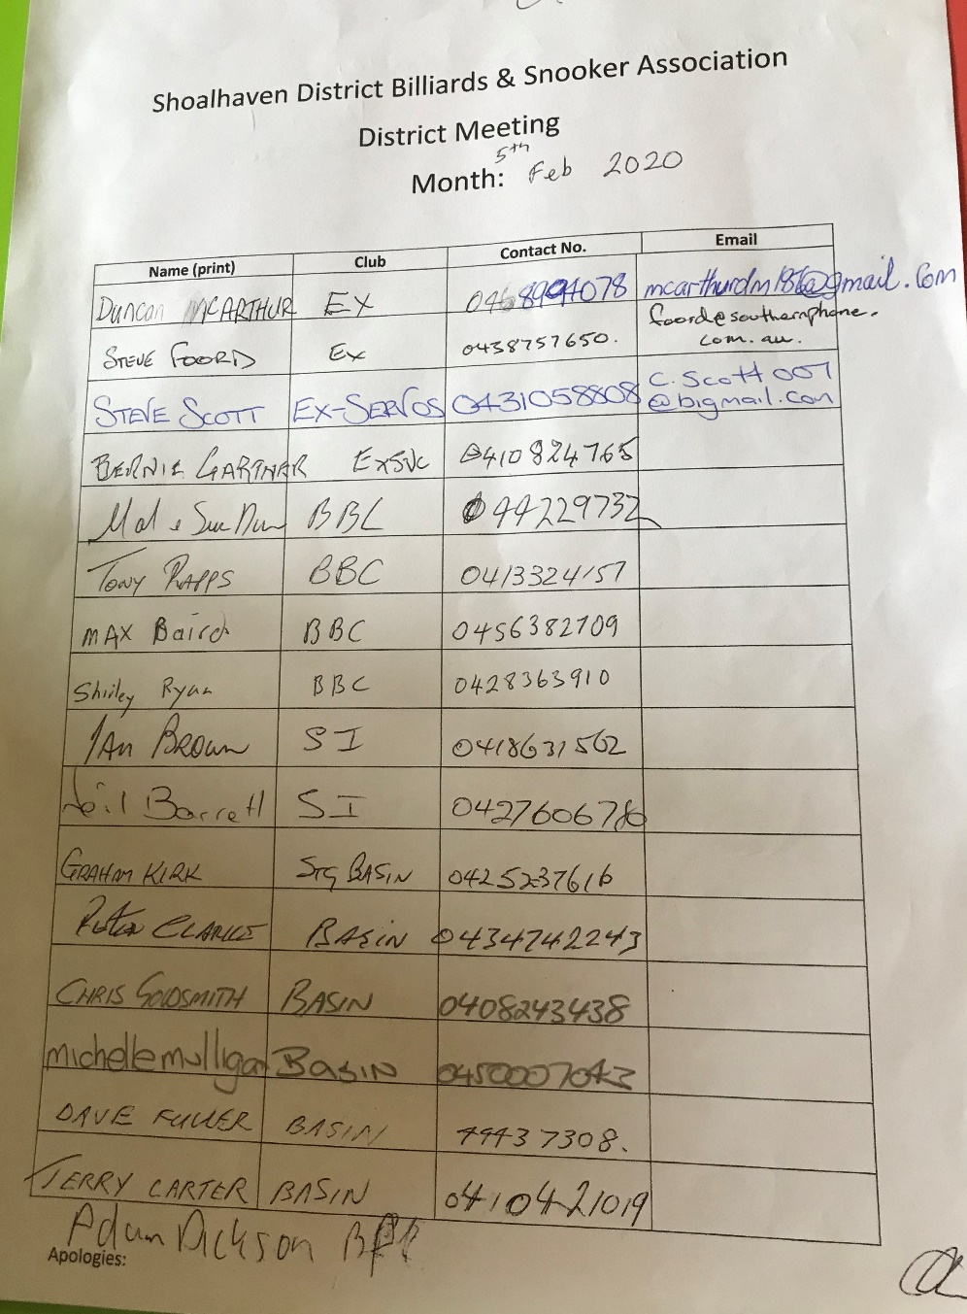
5th February 2020
Opened 7.00pm
Present

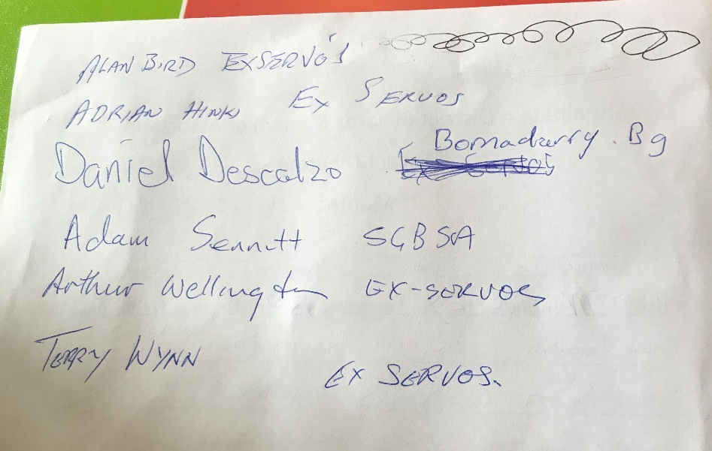

Apology Dave Hazel
Steve Foord opened and welcomed everyone to the AGM.
Everyone was given the minutes from last meeting to read.
Steve Foord declared All positions are vacant.

Terry Carter Nominated Dave Fuller for President
Seconded Michelle Mulligan
Dave Fuller accepted
All in Favour

Shirley Ryan Nominated Adam Sennett for Vice President
Seconded Max Baird
Adam Sennett accepted
All in favour

Max Baird nominated Shirley Ryan for Secretary
Seconded Daniel Descalzo
Shirley Ryan accepted
All in Favour

Dave Fuller Nominated Adam Sennett for Recorder
Seconded Adam Dickson
Adam Sennett accepted
All favour

Shirley Ryan nominated Sue Davis for Treasurer
Seconded Mal Davis
Sue Davis accepted
All in favour

Dave Fuller nominated Michelle Mulligan for Match Secretary
Seconded Peter Clarke
Michelle Mulligan accepted
All in favour
2020 Committee
President Dave Fuller
Vice President Adam Sennett
Secretary Shirley Ryan
Recorder Adam Sennett
Treasurer Sue Davis
Match Secretary Michelle Mulligan
AGM closed 7.25pm

