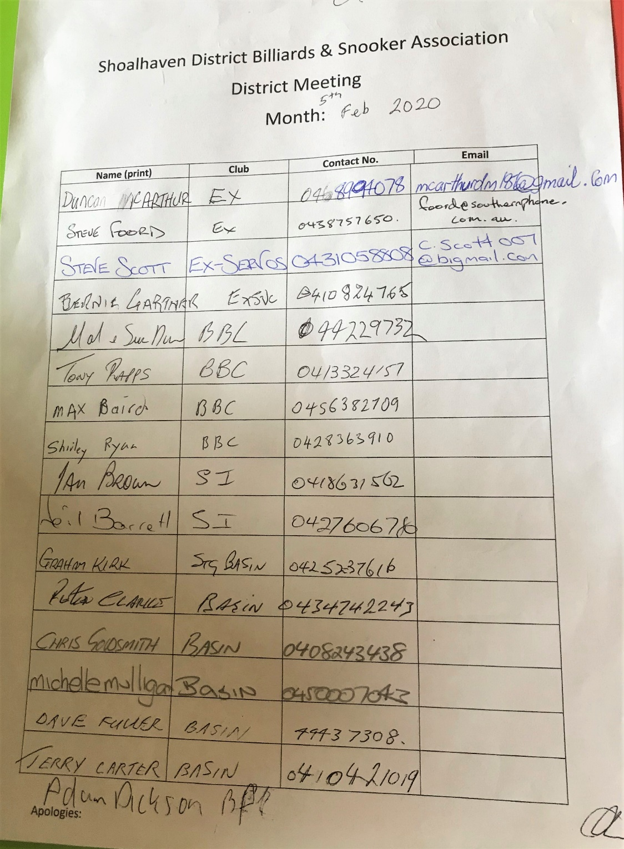
General meeting 5th Feb 2020
Meeting opened 7.25pm
present

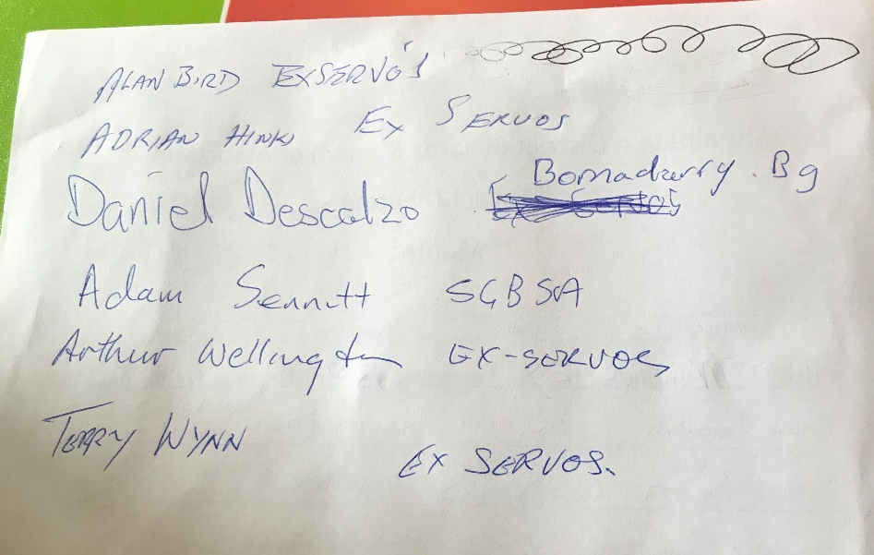

Apology Dave Hazel

Dave Hazel sent a letter giving his resignation and offering help to anyone who takes on the recorders position

Minutes read from last meeting
Anything arising from the minutes
Shirley Ryan said the $50 fine has always been in
And no-one ever gets fined.
Dave Fuller said they will now.
Terry Winn move that the minutes be accepted
Seconded Adam Sennett
All in favour

Treasurers report was read
$4,519.47in bank
Sue said The G’day Australia committee(the web site)
are hard to contact and send to wrong email address
Sue moved that her Treasurers report be accepted
Seconded Adam Sennett

Teams so far this year
Ex services A1
B2
C1
BBC A1
B3

SUSSEX A1
B & C 18 PLAYERS

BASIN A2
B4

CURRARONG B1 ?

Percentages will be looked at half way through the year.
Steve Foord move that A grade will be off scratch and B graders that are deemed B grade playing in A grade will get 15 start. If they are doing better than expected their handicap may be dropped by 5 points at a time. Depending on results this may be adjusted again.

Seconded Mal Davis
All Clubs passed this motion.

Chris Goldsmith moved that
B & C will be combined again like last year.
It will be run and then split into 2 groups after everyone has played each other once.
All points will be carried through after the split.
There will be 4 groups of handicaps in B grade.
A graded players playing B will be on -15 points
B1 0
B2 10
B3 20
Players Handicaps will be reviewed if needed.
Seconded Steve Foord
All Clubs passed motion
Dave Fuller thanked all the leaving committee members for all their work.
General business
Chris Goldsmith started a discussion on 50th anniversary. Maybe a tournament in each club. Maybe get all clubs (including ex clubs) colours on shirts.
Steve Foord is going to bring a sample to the next meeting.

Discussion on players not turning up for competitions.
Clubs should pay total for each club.

Discussion on dress code.
Players must dress appropriately.
Neat clean and tidy
No track pants, no torn clothing, no shorts or thongs.

Fees will be the same as last year.
$35 per player and $140 per team.
Fees need to be paid before each player starts in the competition.

If there are any complaints about handicaps or any other issues anyone needs to be brought up at a meeting. A meeting will go a lot quicker if an email can be sent to Shirley Ryan to go on the coming months agenda. This will give all clubs a chance to talk to their members on this subject before the meeting.

Shirley Ryan would like a list from each club of team captains and their phone numbers to be given out to each club.

Sue Davis asked that all fees be paid directly into the account. She will bring account details next meeting

Terry Winn thanked last years committee.

Next meeting
Thursday 5th March at 7.00pm at the country club
Comp starts 2 weeks later.

Meeting closed 8.30pm

