Meeting opened 7.41pm
Attendance:
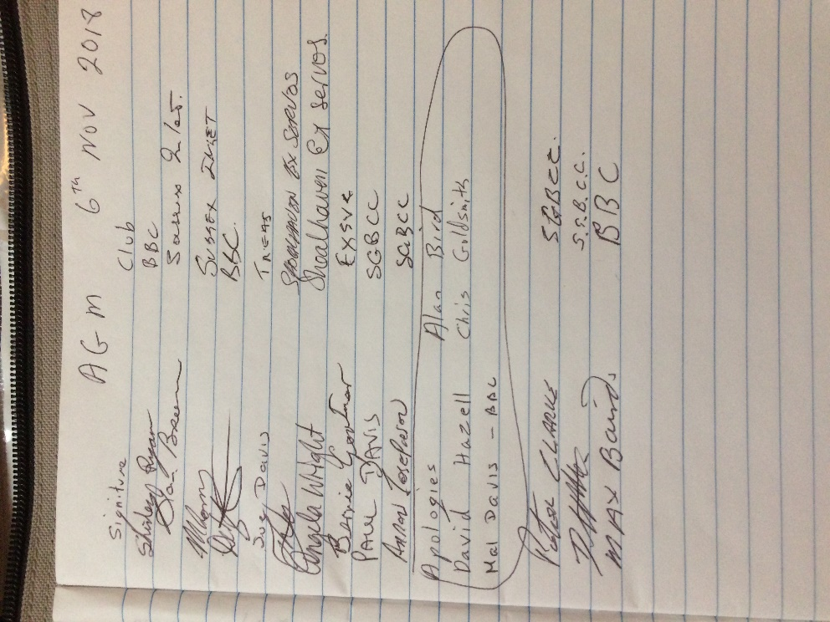
Apologies:
David Hazel, Alan Bird, Chris Goldsmith, Mal Davis, Gareth Jones.
Minutes of last General meeting read.
Sue Davis moved that the minutes be accepted
Seconded Dave Wallington
All in favor
Correspondence
Shirley Ryan and Paul Davis read a letter from Paul Davis on behalf of a group of A grade players.
These proposals were discussed by all attendees of the meeting and it was decided that it would be better for these proposals be discussed at each club and then voted on at the 1st meeting next year.
Shirley Ryan read a letter sent from Dave Hazell about what he proposed for an adjusted handicap for next year.
It was discussed and it was decided that this proposal would be sent out to clubs for discussion to be decided at the 1st meeting next year.

Secretaries report
Dave Wallington Moved that the secretaries report be accepted
Seconded Tony
All in favour

Treasurers report
Balance $3,788.83
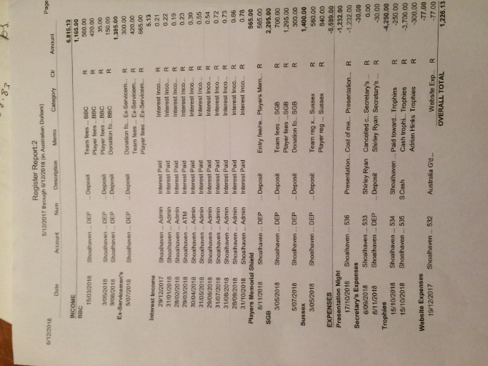
Sue says Adrian Hinks has not sent an account for the trophies.
Moved Sue Davis that the Treasurers report be accepted
Seconded Shirley Ryan
All in favor
General Business
Discussion on paying first before the day of a tournament so there are no forfeits.
Tony move that all monies for all tournaments must be sent to Sue Davis (Preferably one payment from each club) before the draw is made or players will not be entered into the tournament.
Seconded Shirley Ryan
All in favor
Paul said him & his team were disappointed that the Bomaderry team left early.
Tony said that in their defence they were left to one side of the club and it didn’t seam that anything was going to happen, so they left.
Paul also said there was no committee member at the club to officiate at a grandfinal.
Mal Davis was asked to work at the last minute.

It was discussed that grandfinal venues be decided at the beginning of the year.
This can be put on next meeting agenda.
Food at semis/finals and grandfinals.
Agenda for next meeting.
Meeting closed 8.30pm
Next meeting will be at the
Basin on
7pm on Thursday 7th February 2019
Secretary
Shirley Ryan
shirleyryn@yahoo.com.au

