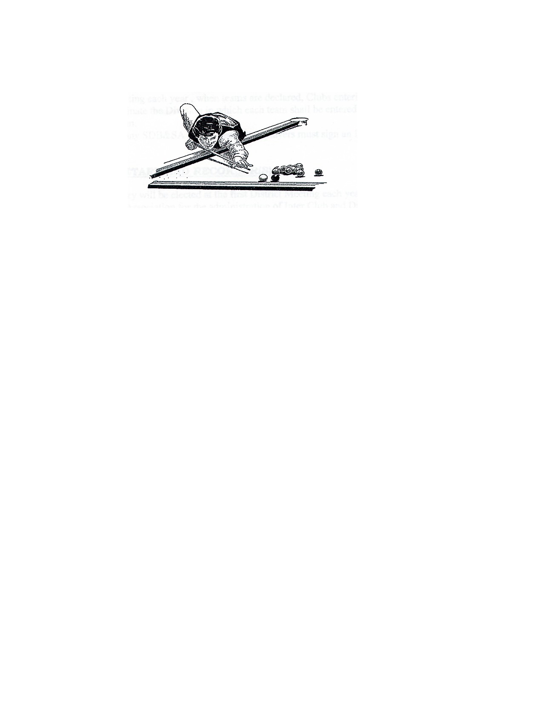

**l**

**SHOALHAVEN DISTRICT BILLIARDS & SNOOKER ASSOCIATION**

**SECRETARY: Dave Fuller**

**Ph: 02 4443 7308**

**Email: frankfuller@aapt.net.au**

**Minutes of the district meeting held Thursday 4th April 2019 at St. Georges Basin Country Club**

**Meeting opened … 7.05 pm**

**CHAIRMAN: Terry Wynn (President) Ph: Mob: 0410 471 707**

**APOLOGIES:**  Mal Gorry, Ian Brown, Peter Clarke, Dave Hazel

**COMMITTEE IN ATTENDANCE:**  Terry Wynn, Bernie Gartner, Dave Fuller, Sue Davis, Mal Davis

**DELEGATES IN ATTENDANCE:** Chris Goldsmith, Michelle Mulligan, Tim Howe

**PREVIOUS MINUTES ACCEPTED AS READ:**

Moved: Mal Davis Seconded: Dave Fuller

**BUSINESS ARISING FROM PREVIOUS MINUTES:**

Chris Goldsmith mentioned that the previous minutes read as if there was no C grade this year. This is incorrect as B & C grade have been combined until the end of the first round. After this the top 7 and the bottom six will become B1 & B2.

**CORRESPONDANCE:**

**IN:** Shirley Ryan sent 2 emails.

**OUT**

**TREASURERS REPORT (as of)** (Sue Davis)

Current Bank Balance: - $4651.89

Interest earned -

Moved: **Sue Davis** Seconded: **Bernie Gartner**

**BUSINESS ARISING FROM TREASURERS REPORT:**

.Nil

**RECORDERS REPORT**

NIL

**MATCH SECRETARY REPORT** (Mal Davis)

Mal Davis mentioned that some players were confused by the 50% on the web-site. This has been rectified with all new players now having a 0% on the web-site. After new players have played 6 frames they will be given a new percentage based on results.

**HANDICAPPERS REPORT**

Mal Davis said that Max Baird’s handicap should be 29%. Terry Wynn mentioned that Mal Davis & Dave Hazell become the Handicap Committee.

**GENERAL BUSINESS**

**Terry Wynn**- mentioned that a new secretary was needed due to Shirley Ryan resigning. Terry asked Dave Fuller would he take on the position and he accepted. Moved by Terry Wynn and Seconded by Bernie Gartner.

**Dave Fuller**- mentioned that more discussion was needed about the Summer Cup.

**Sue Davis**- mentioned that a venue should be considered for Presentation Night and after discussion it was decided that it should be held at Shoalhaven Ex-Servicemens Club.

**Michelle Mulligan**- mentioned Dave Smith is now playing down a grade and his handicap should be looked at to make it fair.

**Meeting closed 8.04pm**

**Next meeting Thursday 2nd May**

**Shoalhaven Ex-Servicemens Club**